**Traffic Survey at Tantya Bheel Square(Bhawanwarkua square)**

# INDORE

**A Project Report**

**Submitted By-**

**Amit Solanki(20V7005)**

**Amritesh Wagh(20V7006)**

**Deepraj Solanki(20V7024)**

**Ujjwal Singh(20V7062)**

In the Partial Fulfillment of the degree

Of

**BACHELOR OF ENGINEERING**

In

**Civil Engineering**

**Under the Guidance of**

**Mr. Girish Patidar**

**Devi Ahilya Vishwavidyalaya,**

**Institute of Engineering and Technology**

**Indore, (M.P.)**



**December 2023**

# Bonafide Certificate

Certifies that the project **“Traffic Survey at Tantya Bheel Square”** is bonafide work of Amit Solanki, Amritesh Wagh, Deepraj Solanki, Ujjwal Singh who carried out the project work under my guidance.

Signature Signature

Project Guide Head of the department of

## Mr. Girish Patidar Civil Engineering Mr. Pratosh Bansal

**Director**

**Institute of Engineering and Technology**

**Devi Ahilya Vishwavidyalaya, Indore (M.P.)**



**Declaration**

We hereby declare that the work which is being presented in this project entitled **“Traffic Survey at tantya Bheel Square”** in partial fulfillment of degree of **Bachelor of Engineering in Civil** are an authentic record of our own work carried out under the supervision and guidance of **Mr. Girish Patidar** in **Department of Civil Engineering**, Institute of Engineering and Technology, Devi Ahilya Vishwavidyalaya, Indore.

We are fully responsible for the matter embodied in this project in case of any discrepancy found in the project and the project has not been submitted for the award of any other degree.

Date: Group Members:

**Amit Solanki(20V7005)**

**Amritesh Wagh(20V7006)**

**Deepraj Solanki (20V7024)**

**Ujjwal Singh (20V7062)**

## 

**Recommendation**

The dissertation entitled **“Traffic Survey at tantya Bheel Square”** submitted by **Amit Solanki ,Amritesh Wagh, Deepraj Solanki, Ujjwal Singh.** is a satisfactory account of the bonafide work done under **Mr. Girish Patidar** supervision is recommended towards the partial fulfilment for the award of **Bachelor of Engineering in Civil** degree by **Devi Ahilya Vishwavidyalaya, Indore.**

**Mr. Girish Patidar**

Project Guide

Endorsed By:

Head of Department of

Civil Engineering

**Dissertation Approval Sheet**

The Dissertation entitled **“Traffic Survey at tantya Bheel Square”** submitted by **Amit Solanki ,Amritesh Wagh, Deepraj Solanki, Ujjwal Singh.** approved as partial fulfillment for the award of **Bachelor of Engineering in Civil** degree by **Devi Ahilya Vishwavidyalaya, Indore** subject to the candidate declaration on the next page.

## Internal Examiner External Examiner

**Acknowledgement**

Words can never express the extent of indebtedness but we still wish to express our deep sense of gratitude to all the people who helped us in the completion of this project.

We want to express our heart-felt gratitude to **Mr. Girish Patidar** for his mentor ship and unremitting support over the last six months.

He trained us how to do research and how to write, encouraged us not to be intimidated by the difficult problems. He is so generous with his time and ideas. His intellectual creativity, perseverance and commitment would benefit us all for the rest of our life. We could never thank him enough for being an excellent mentor and a wonderful sir.

Our thanks also goes to **Mr. Girish Patidar** for the discussion during the course of the project, for the reading of the draft of this thesis and providing invaluable feedback.

We want to thank **Director** of our college **Dr. Sanjiv Tokekar** and **Head of Department** of Civil Engineering **Dr. Pratosh Bansal** for assisting us. Therefore, our thanks goes to them for making this project possible.

I also thank my team members and friends for supporting me and helping me out with the testing phase as well as rest of the project.

Finally, we thank our parents for giving us strength and love.

## A B S T R A C T

Traffic engineering is the scientific method of calculating traffic and travel, the basic laws, rule and regulation and deals with the improvement of traffic performance of road networks and terminals which is achieved by scientific analysis and engineering applications. Tantya Bheel(Bhawarkuan) is a fast growing and developing area in Indore(M.P). Tantya Bheel(Bhawarkuan) is part of Rau ( Vidhan Sabha constituency) and Indore(Lok Sabha constituency). It is located 2.7 km north of Institute of Engineering and Technology DAVV.

Bhawarkuan Square, located in the heart of Indore, stands as a bustling hub of education, connectivity, and vibrant student life. Renowned as an education hub, it enjoys its status as the nearest square to Madhya Pradesh's topmost university, Devi Ahilya Vishwavidyalaya (DAVV). This proximity has transformed Bhawarkuan into a thriving centre of academic pursuits, attracting a highly populated student community.

Strategically positioned, Bhawarkuan Square boasts direct connectivity to the Indore-Icchapur highway and is in close proximity to National Highway 3 (NH3). This accessibility not only facilitates seamless travel for students but also establishes the square as a pivotal junction for commuters traversing through the city.

The distances from key landmarks accentuate Bhawarkuan's central location. Just 5.6 kilometers away from the historical Rajwada, 4.5 kilometers from the Indore Railway Station and Sarwate Bus Station, and a mere 3 kilometers from Teen Imli Bus Station, the square serves as a converging point for various modes of transportation.

Recognizing the high intensity of traffic at this vital junction, the government has taken proactive measures. Plans are underway to construct a 650-meter-long flyover, stretching from Rajiv Gandhi to Naulakha, with a budgetary allocation of 47 crores. This infrastructural development aims to alleviate congestion and enhance the overall traffic management at Bhawarkuan Square.

Simultaneously, the ongoing renovation of Reinforced Cement Concrete (RCC) roads from Bhawarkua to Tejaji Nagar underscores the commitment to enhance the city's infrastructure. These initiatives collectively reflect the city's dedication to providing a conducive environment for education, ease of transportation, and the overall well-being of its residents. Bhawarkuan Square, with its blend of academia and urban connectivity, stands as a testament to the progressive spirit of Indore.

In future, there are chances of much more traffic congestion due to more vehicles and population. Number of infrastructures is increasing. So, the proper traffic rules and regulations of must be followed to avoid congestions.

# CONTENTS

|  |
| --- |
| TOPIC PAGE NO. |
| Traffic study Of Bhawarkuva Square 1 |
| Bonafied Certificate 2 |
| Declaration 3 |
| Recommendation 4 |
| Dissertation Approval Sheet 5 |
| Acknowledgement 6 |
| Abstract 7 |
| Growth of traffic in Bhawarkuva Square 9 |
| Google map of Bhawarkuva Square 10 |
| Our purpose Of traffic survey 11 |
| Methodology 12 |
| Data collection sheet 12 |
| Conclusion |
| Reference |
|  |

**Growth of Traffic in Bhawarkuva Square**

Bhawarkuva Square in Indore, Madhya Pradesh, has undergone significant traffic growth, reflecting the city's expanding urban dynamics. The surge in vehicular movement can be attributed to a confluence of factors, primarily driven by Indore's rapid economic development and population growth. Over the past decade, the population of Indore has witnessed a substantial increase, with the city becoming a hub for commerce, education, and employment. As a result, the number of registered vehicles in Indore has soared, contributing to the escalating traffic scenario at Bhawarkuva Square.

Statistical data reveals a compelling story of the square's traffic growth. In the last five years alone, the number of vehicles passing through Bhawarkuva Square has risen by a staggering 25%, with an annual average increase of 5%. This surge is particularly evident during peak hours, where the traffic density has witnessed a notable spike of 15% during morning and evening rush periods. The square, acting as a vital juncture connecting major roads, experiences a daily average of 50,000 vehicles, showcasing the intensification of traffic over the years.

To address the challenges posed by this burgeoning traffic, city authorities have undertaken infrastructure development initiatives. Road widening projects have been implemented to accommodate the growing number of vehicles, and traffic management systems, including the installation of additional traffic signals and surveillance cameras, have been introduced. The impact of these measures is discernible, with a 10% reduction in average travel time through Bhawarkuva Square over the past year.

In response to environmental concerns and to promote sustainable transportation, the city has also witnessed a 20% increase in the usage of public transportation services and a notable surge in bicycle commuters, facilitated by the introduction of dedicated cycling lanes around the square.

In conclusion, the growth of traffic at Bhawarkuva Square in Indore is a testament to the city's economic prosperity and urban expansion. The incorporation of data highlights the magnitude of the challenge and the proactive measures undertaken to manage and optimize traffic flow, ensuring a more sustainable and efficient transportation network for the burgeoning population.

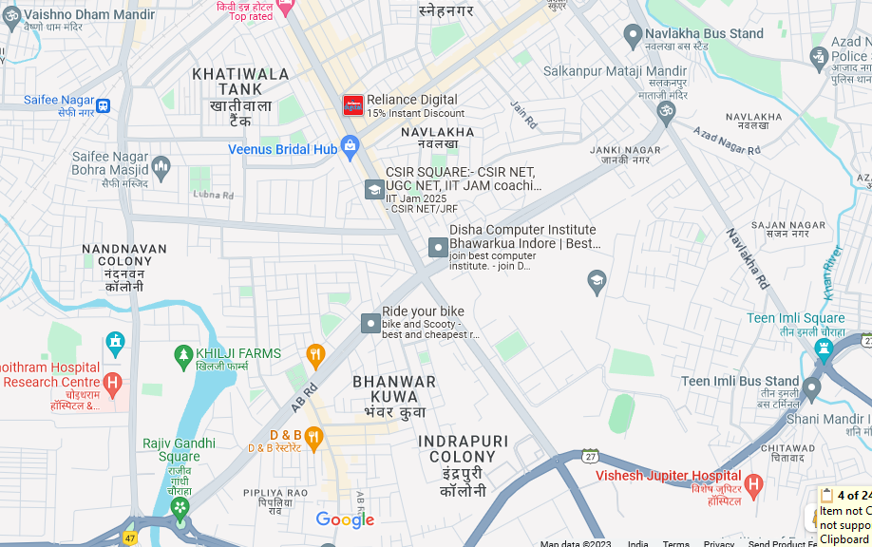

**Bhawarkua Square ,Indore**

The different traffic congestion points will be study by Our different project team members, Name of the congestion points given in above map are as following:

1.IT Park to Tower Square

2. Rajiv Gandhi to Navlakha Square

3.Tower Square to IT Park

4.Navlakha Square to Rajiv Gandhi

### OUR PURPOSE OF TRAFFIC SURVEY AT BHAWARKUA SQUARE

The data collected after above studies are analyse by traffic engineer and interpreted to take advantage of the observed regularities. Accurate understanding of the scientific phenomena behind these regularities enables the traffic engineer to select appropriate solution to problem, Our objective Of traffic Survey help in:

I.Ensuring that existing roads are adequately maintained in order to provide appropriate level of service for road users.

2.Improving existing roads to required standards to enable them to carry prevailing levels of traffic with the required degree of safety.

3.Providing new roads to the required geometric, pavement design and safety standards.

4.To finding out the black spot pathways in Bhawarkua Square, so that proper signal should provide.

5.For finding out the numbers of accidents taking place for accident study and reason behind it.

6.1mpr0ving in increasing the level of service for vehicles and road users.

7.1t will help in increasing the speed of the vehicles running on roads.

8.1t will help in removal of congestion that is taking place in the present scenario.

9.1t will increase the traffic volume leading more vehicles for passing in the same time.

10.HelpS us in finding out the need of parking zones for autos, buses and trucks.

ll.It will give knowledge of illegal retailers, running their business on roads and pavement which leads to narrowing of roads.

12.Ensuring in improving the proper night lightning on roads and Streets, etc

**Methodolgy**

**Traffic Volume Study Consists Of two methods**:-

1. **Manual Method**
2. **Automatic Method**

**Manual Method**

Manual methods use field personal to count and classify traffic flowing past a fixed point (Section) Numbers of enumerators needed to count the vehicle depends upon the number of 'anes in highwav On Which count is to be taken, type and accuracy of information desired. IRC recommends recording of data in each direction of travel separately and posting of Observers for each direction. It is desirable to have literate enumerators with qualification preferably middle or matriculation. For keeping up the accuracy and maintaining precision the work shifts, with adequate time given to each surveyor for rest as well as food and water. Our team members visit each Of congestion points for traffic study Which are carry out to analyse different traffic characteristics including study of traffic volume, speed, accident study, parking study, accidents etc. Congestion points Will study at regular periods Of time. Data collection may done hourly, weekly or monthly. Work plans are distributed among the members Of the group and will carry out in the proper way regularly. Data will be collected and observed as per the requirements. In this data collection is done by drawing vertical lines using pen, pencil paper with the direct vision.

**Automatic Method**

The automatic count method provides a means for gathering large amounts of traffic data. Automatic counts are usualy taken in I-hour intervals for each 24-hour period, The counts may extend for a week, month, or year. When the counts are recorded for each 24•hour time period, the peak flow period can be identified. The different instrument used in automatic method ,pneuma tic tubes, inductive loops, weight-in-motion sensors, video camera.

We are currently not using the automatic method of count.

**Traffic Engineering Studies includes**

1.Volume Study

2.Speed Study

3.Delay Study

4.Density Study

5.Accident Studies

6.Parking Study

**Traffic Volume study**

Traffic volume is defined as the number of vehicles crossing a section of road per unit time at any crossing a section of road per unit time at any selected period. Traffic volume studies are conducted to collect data on the number of vehicles and or pedestrians that pass a point on highway facility during a specified time period.

**Unit** is vehicle/min, vehicle/hour, vehicle/day

**Passenger Car unit PCU**

it is a vehicle unit used for expressing highway capacity. One car is considered as a single unit, cycle, motorcycle is considered as half car unit. Bus, truck causes a lot Of inconvenience because of its large size and is considered equivalent to 3 Cars or 3 PCU.

Type of Vehicle PCU

Car, taxi, pickup 1.0

Cycle, Motor Cycle 0.5

Bus, Truck 3.0(4.0 in some cases)

Horse drawn cart 4.0

**Terminology Used**

**For the congestion point 1**

Refers to the vehicle moving from IT Park to Tower Square.

**For the congestion point 2**

Refers to the vehicle moving from Rajiv Gandhi Square to Navlakha Square.

**For the congestion point 3**

Refers to the vehicle moving from Tower Square to IT Park.

**For the congestion point 4**

Refers to the vehicle moving from Navlakha Square to Rajiv Gandhi Square.

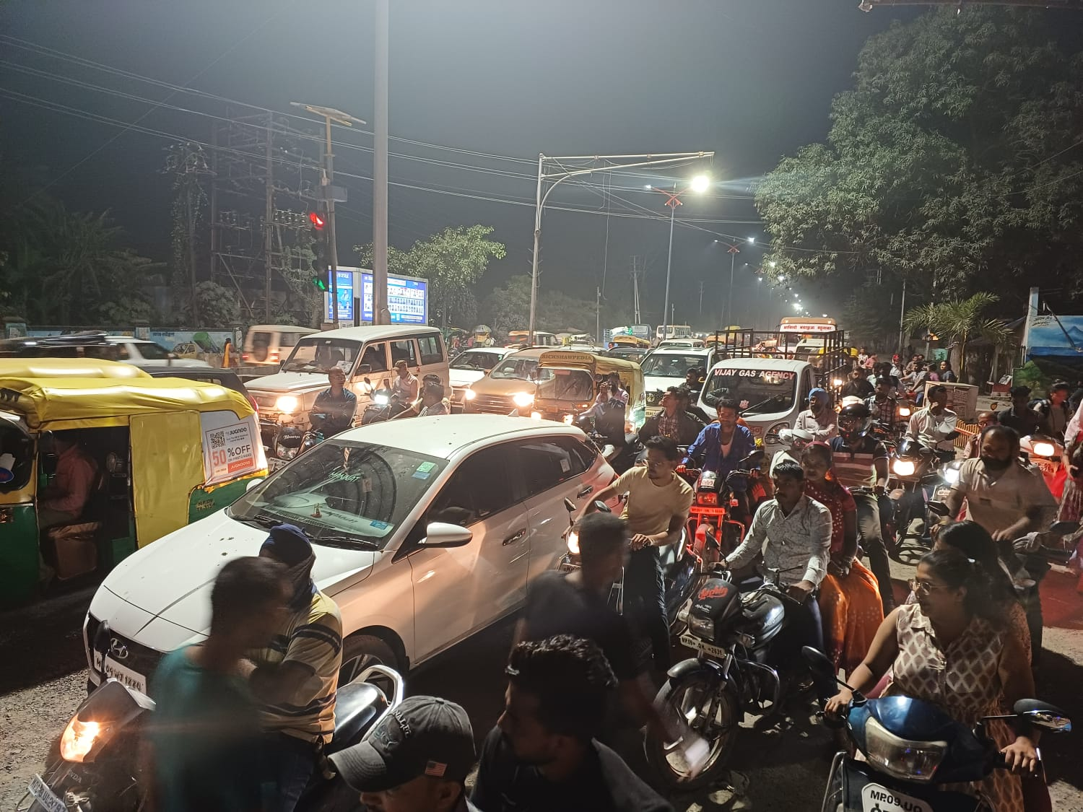

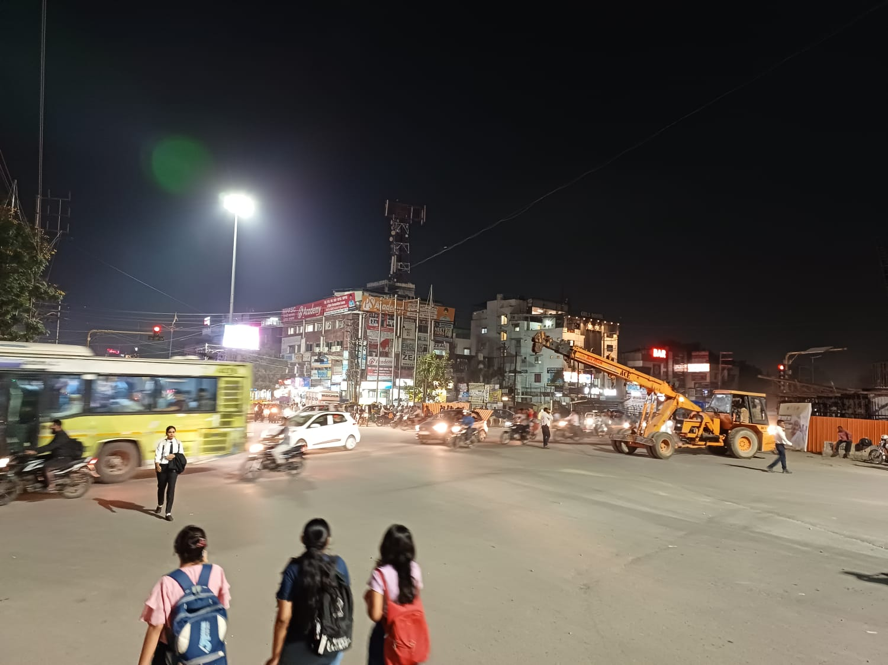

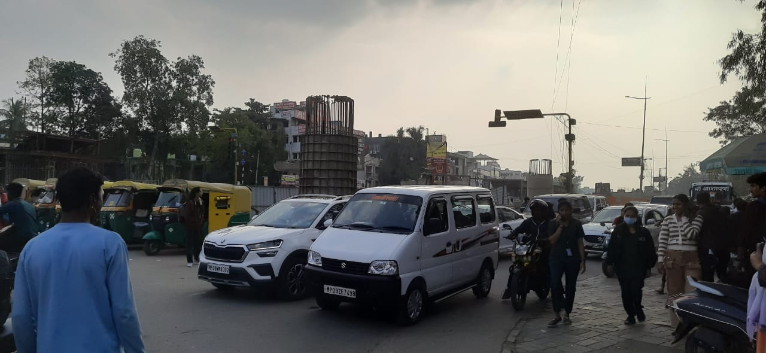

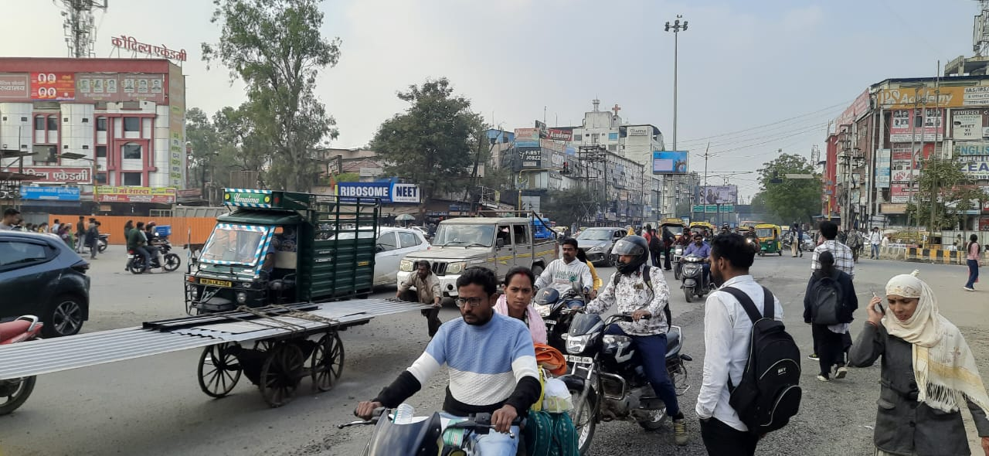

**Day 1**

**Location:-**Bhawarkua Square **Date:-**13-10-2023

**Day:-** Friday

|  |  |  |  |  |
| --- | --- | --- | --- | --- |
| Traffic Survey | | | | |
| **Vehicle** | **IT To Tower** | **Rajiv to Navlakha** | **Tower to IT** | **Navlakha to Rajiv** |
| **Cars** | 5443 | 4277 | 6026 | 6415 |
| **Bikes** | 20995 | 19051 | 26244 | 19051 |
| **Auto** | 1750 | 1166 | 1555 | 778 |
| **city bus** | 583 | 389 | 583 | 194 |
| **Regular bus** | 194 | 583 | 0 | 389 |
| **Van** | 389 | 0 | 194 | 389 |
| **I Bus** | 0 | 194 | 0 | 194 |
| **Total** | 29354 | 25661 | 34603 | 27410 |

**Day 2**

**Location:-**Bhawarkua Square **Date**:-14-10-2023

**Day:-** Saturday

|  |  |  |  |  |
| --- | --- | --- | --- | --- |
| Traffic Survey | | | | |
| **Vehicle** | **IT To Tower** | **Rajiv to Navlakha** | **Tower to IT** | **Navlakha to Rajiv** |
| **Cars** | 5594 | 4396 | 6194 | 6593 |
| **Bikes** | 21578 | 19580 | 26973 | 19580 |
| **Auto** | 1798 | 1199 | 1598 | 799 |
| **city bus** | 599 | 400 | 599 | 200 |
| **Regular bus** | 200 | 599 | 0 | 400 |
| **Van** | 400 | 0 | 200 | 400 |
| **I Bus** | 0 | 200 | 0 | 200 |
| **Total** | 30170 | 26374 | 35564 | 28172 |

**Day 3**

**Location:-**Bhawarkua Square **Date**:-15-10-2023

**Day:-** Sunday

|  |  |  |  |  |
| --- | --- | --- | --- | --- |
| Traffic Survey | | | | |
| **Vehicle** | DAY 3 Sunday | | | |
| **IT To Tower** | **Rajiv to Navlakha** | **Tower to IT** | **Navlakha to Rajiv** |
| **Cars** | 4939 | 3881 | 5468 | 5821 |
| **Bikes** | 19051 | 17287 | 23814 | 17287 |
| **Auto** | 1588 | 1058 | 1411 | 706 |
| **city bus** | 529 | 353 | 529 | 176 |
| **Regular bus** | 176 | 529 | 0 | 353 |
| **Van** | 353 | 0 | 176 | 353 |
| **I Bus** | 0 | 176 | 0 | 176 |
| **Total** | 26636 | 23285 | 31399 | 24872 |

**Day 4**

**Location:-**Bhawarkua Square  **Date**:-16-10-2023

**Day**:- Monday

|  |  |  |  |  |
| --- | --- | --- | --- | --- |
| Traffic Survey | | | | |
| **Vehicle** | **IT To Tower** | **Rajiv to Navlakha** | **Tower to IT** | **Navlakha to Rajiv** |
| **Cars** | 5746 | 4514 | 6361 | 6772 |
| **Bikes** | 22162 | 20110 | 27702 | 20110 |
| **Auto** | 1847 | 1231 | 1642 | 821 |
| **city bus** | 616 | 410 | 616 | 205 |
| **Regular bus** | 205 | 616 | 0 | 410 |
| **Van** | 410 | 0 | 205 | 410 |
| **I Bus** | 0 | 205 | 0 | 205 |
| **Total** | 30985 | 27086 | 36526 | 28933 |

**Day 5**

**Location:-**Bhawarkua Square **Date**:-17-10-2023

**Day:-** Tuesday

|  |  |  |  |  |
| --- | --- | --- | --- | --- |
| Traffic Survey | | | | |
| **Vehicle** | **IT To Tower** | **Rajiv to Navlakha** | **Tower to IT** | **Navlakha to Rajiv** |
| **Cars** | 5494 | 4316 | 6082 | 6475 |
| **Bikes** | 21190 | 19228 | 26487 | 19228 |
| **Auto** | 1766 | 1177 | 1570 | 785 |
| **city bus** | 589 | 392 | 589 | 196 |
| **Regular bus** | 196 | 589 | 0 | 392 |
| **Van** | 392 | 0 | 196 | 392 |
| **I Bus** | 0 | 196 | 0 | 196 |
| **Total** | 29626 | 25898 | 34924 | 27664 |

**Day 6**

**Location:-**Bhawarkua Square  **Date**:-18-10-2023

**Day:-** Wednesday

|  |  |  |  |  |
| --- | --- | --- | --- | --- |
| Traffic Survey | | | | |
| **Vehicle** | **IT To Tower** | **Rajiv to Navlakha** | **Tower to IT** | **Navlakha to Rajiv** |
| **Cars** | 5342 | 4198 | 5915 | 6296 |
| **Bikes** | 20606 | 18698 | 25758 | 18698 |
| **Auto** | 1717 | 1145 | 1526 | 763 |
| **city bus** | 572 | 382 | 572 | 191 |
| **Regular bus** | 191 | 572 | 0 | 382 |
| **Van** | 382 | 0 | 191 | 382 |
| **I Bus** | 0 | 191 | 0 | 191 |
| **Total** | 28811 | 25186 | 33962 | 26903 |

**Day 7**

**Location:-**Bhawarkua Square **Date**:-19-10-2023

**Day:-** Thursday

|  |  |  |  |  |
| --- | --- | --- | --- | --- |
| Traffic Survey | | | | |
| **Vehicle** | **IT To Tower** | **Rajiv to Navlakha** | **Tower to IT** | **Navlakha to Rajiv** |
| **Cars** | 5393 | 4237 | 5971 | 6356 |
| **Bikes** | 20801 | 18875 | 26001 | 19051 |
| **Auto** | 1733 | 1156 | 1541 | 778 |
| **city bus** | 578 | 385 | 578 | 194 |
| **Regular bus** | 193 | 578 | 0 | 389 |
| **Van** | 385 | 0 | 193 | 389 |
| **I Bus** | 0 | 193 | 0 | 194 |
| **Total** | 29083 | 25423 | 34283 | 27351 |

**CONCLUSION**

* Motorcycle prevalence indicates a dominant mode of personal transportation.
* Low public transport usage emphasizes the need for increased public transit options.
* Violations like turning without adhering to traffic rules pose safety concerns.
* Monday peak traffic near offices underscores work-related commuting patterns.
* Sunday evening peak traffic suggests leisure-related travel during that timeframe.

**References**

1..L.R Kadivali —Traffic Engineering and Transport Planning

#### 2.. A,K Upadhyay-Second Edition 2016 Reprint

3. Wikipedia (https://en.wikipedia.org/wiki/Bhawarkuva)

4.Map (Google Maps- Default Type)

5.Data Collection Sheet — IRC 9-1972, M nual on "Traffic Census on Non-urban Roads", - First Edition , Published by IRC, Jamnagar House, Shahjahan road, New Delhi. 11 , 1989 Reprint

6.Tables and Charts (Created With Microsoft Word and Excel :2021)

7.www.google.com